SCREENSHOTS FOR MACHINE PROBLEM 3(MATLAB)

**SCRIPT:**

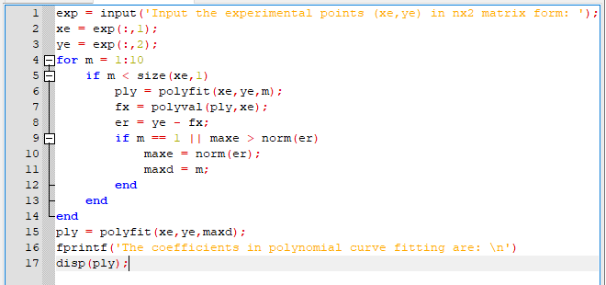

**OUTPUT:**

